July Wellman

CS 470: Full Stack Development II

Southern New Hampshire University

September 24, 2025

**Lamba and Gateway API**

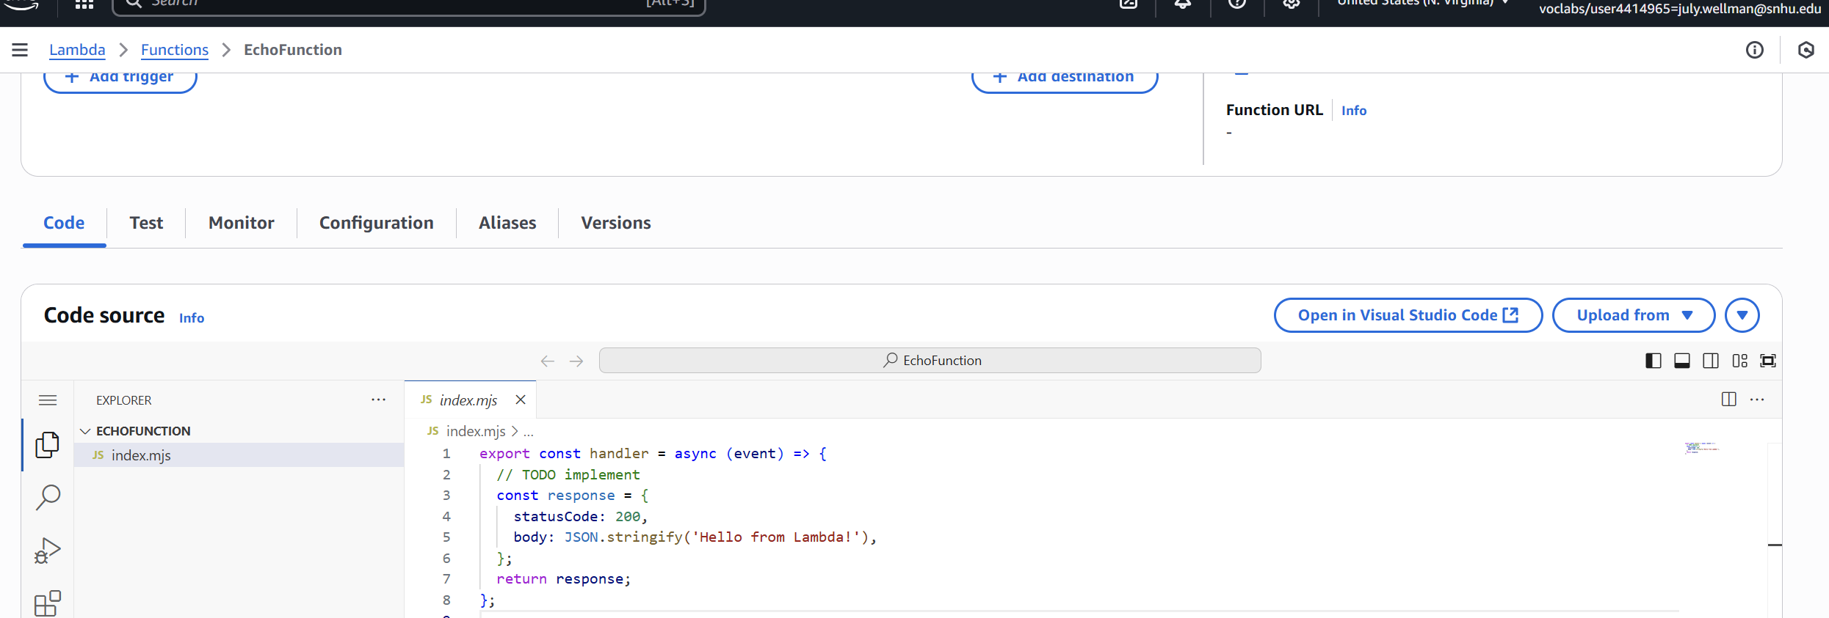

*First serverless compute function*

*Execution results*

*EchoWithQuery execution results*

*Screenshot or JSON for the created test event “EchoWithQuery”*

*Source code or screenshot for index.js (about 22 lines of code)*